CPE301 – SPRING 2019

Design Assignment 2, Part C

Student Name: James Skelly

Student #: 2000945485

Student Email: skellj1@unlv.nevada.edu

Primary Github address: https://github.com/skellj1/submission_da

Directory: skellj1/submission_da

Submit the following for all Labs:

1. In the document, for each task submit the modified or included code (only) with highlights and justifications of the modifications. Also, include the comments.
2. Use the previously create a Github repository with a random name (no CPE/301, Lastname, Firstname). Place all labs under the root folder ESD301/DA, sub-folder named LABXX, with one document and one video link file for each lab, place modified asm/c files named as LabXX-TYY.asm/c.
3. If multiple asm/c files or other libraries are used, create a folder LabXX-TYY and place these files inside the folder.
4. The folder should have a) Word document (see template), b) source code file(s) and other include files, c) text file with youtube video links (see template).
5. **COMPONENTS LIST AND CONNECTION BLOCK DIAGRAM w/ PINS**

* Components used for this assignment include Atmel Studio 7, MultiFunction Shield, X-plained Mini Microcontroller board with ATmega328p chip on board, and mEDBG programmer /debugger. Youtube was used to post video, my iPhone was used to record video, and the Tektronix TDS 2014 Oscilloscope was used to measure output waveforms with a 10:1 compensated oscilloscope probe. The block diagram below is specific to part B. This is because no user input is required for part A, and the block diagram would not make much sense.

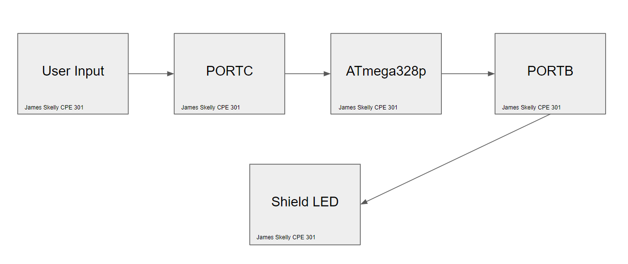

1. **INITIAL/MODIFIED/DEVELOPED CODE OF TASK 1/A**

**PART 1A: Creating a waveform with 60% DC, 0.725 second period using timer0, normal mode.**

/*

* 2C_1A.c

*

* Created: 3/21/2019 11:37:08 PM

* Author : James Skelly

*/

#define *F_CPU* 16000000UL

#include <avr/io.h>

int main(void)

{

*uint8_t* Overflow = 0; // declare overflow variable and initialize to 0

DDRB = 0x04; // set data direction reg. B to output

TCCR0A = 0; // normal mode operation

TCCR0B = 0x05; // prescaler of 1024

TCNT0 = 0x0; // start the timer

while (1)

{

// wait for the overflow event

while ((TIFR0 & 0x01) == 0);

TCNT0 = 0x00; // reset timer0 to 0

TIFR0 = 0x01; // reset overflow flag

Overflow++; // increment overflow variable

if (Overflow == 18) // if statement for 18th overflow of timer0

{ // generate delay of 290 ms

PORTB = 0x00; // sets PORTB.2 high (reverse logic, LED on)

}

if (Overflow == 44) // if statement for 44th overflow of timer0

{ // generate delay of 435 ms

PORTB = 0x04; // sets PORTB.2 low (LED off)

Overflow = 0; // resets overflow counter to 0

}

}

}

**PART 1B: Turn on LED for 1.25 seconds after pressing button using timer0, normal mode.**

/*

* 2C_1B.c

*

* Created: 3/21/2019 11:37:37 PM

* Author : James Skelly

*/

// 2. Connect a switch to PORTC.2 to poll for an event to turn on the LED

// at PORTB.2 for 1.250 seconds after the event.

#define *F_CPU* 16000000UL // Set frequency of CPU to 16 MHz for delay function

#include <avr/io.h> // Including AVR and Delay header libraries

#include <util/delay.h>

int main (void)

{

*uint8_t* Overflow = 0; // Declare overflow variable and initialize to 0

DDRB = 0x04; // Sets DDRB pin 2 to output mode

PORTB = 0x04; // Sets PORTB pin 2 to high

DDRC = 0x00; // Sets DDRC pin 2 to input mode

PORTC =0x04; // Sets PORTC pin 2 to high

TCCR0A = 0x00; // Set timer0 to operate in normal mode

TCCR0B = 0x05; // Set prescaler to 1024

while (1)

{

if (!(PINC & (1<<PINC2))) // Check PINC for a value of 1 for a value of 1,

// complemented to check for a zero instead.

{

Overflow = 0; // reset overflow to 0 when button pressed

TCNT0 = 0x00; // reset timer to 0 when button pressed

PORTB = 0x00; // Turn on LED by setting PORTB.2 to 0.

}

while ((TIFR0 & 0x01) == 0); // check for overflow in overflow flag bit

TIFR0 = 0x01; // reset overflow flag

Overflow++; // increment overflow variable

if (Overflow == 76) // check for 76th overflow to achieve

// desired delay of 1.250 seconds

{

PORTB = 0x04; // turn the LED off after 1.250s

}

TCNT0 = 0; // reset the timer

}

return 0;

}

1. **DEVELOPED MODIFIED CODE OF TASK 2/A from TASK 1/A**

**PART 2A: Implementing Part 1A using TIMER0_OVF_vect interrupt mechanism, normal mode.**

/*

* 2C_2A.c

*

* Created: 3/21/2019 11:38:47 PM

* Author : James Skelly

*/

#define *F_CPU* 16000000UL

#include <avr/io.h>

#include <avr/interrupt.h>

int main(void)

{

DDRB = 0x04; // set PORTB.2 to output

PORTB = 0x04; // initially turn LED at portb.2 off

TIMSK0 = 0x01; // enable timer0 overflow interrupt

TCNT0 = 0x00; // initialize timer0 to 0

sei(); // enable interrupts

TCCR0A = 0x00; // set timer0 to normal mode operation

TCCR0B = 0x05; // set prescaler of 1024

while (1)

{

// main loop

}

}

*uint8_t* Overflow = 0; // initialize overflow variable

ISR (TIMER0_OVF_vect) // interrupt subroutine highlighted to show that this is the part

// of the code that was modified.

{

TCNT0 = 0; // reset timer0 to 0 when interrupt occurs

Overflow++; // increment overflow variable

if (Overflow == 18) // if statement to check for 18th overflow of timer0

{

PORTB = 0x00; // turns LED at PORTB.2 on

}

if (Overflow == 44) // if statement to check for 44th overflow of timer0

{

PORTB = 0x04; // turns LED off

Overflow = 0; // resets overflow variable to 0

}

}

**PART 2B: Implementing Part 1B using TIMER0_OVF_vect interrupt mechanism, normal mode.**

/*

* 2C_2B.c

* Created: 3/21/2019 11:39:09 PM

* Author : James Skelly

*/

#define *F_CPU* 16000000UL

#include <avr/io.h>

#include <avr/interrupt.h>

int button = 0; // initialize global variable for button

int main(void)

{

DDRB = 0x04; // Sets DDRB pin 2 to output mode

PORTB = 0x04; // Sets PORTB pin 2 to high

DDRC = 0x00; // Sets DDRC pin 2 to input mode

PORTC = 0x04; // Sets PORTC pin 2 to high

TIMSK0 = 0x01; // enable timer0 overflow interrupt

sei(); // enable interrupts

TCCR0A = 0x00; // Set timer0 to operate in normal mode

TCCR0B = 0x05; // Set prescaler to 1024

while (1)

{

if (!(PINC & (1<<PINC2))) // Check PINC for a value of 1 for a value of 1,

// complemented to check for a zero instead.

{

button = 1; // activates if statement inside interrupt subroutine

}

else

{

PORTB = 0x04; // keeps LED off until button is pressed

button = 0; // does not enter subroutine if statement

}

}

return 0;

}

ISR (TIMER0_OVF_vect) // highlighted to show that this is the part of the code that was modified

{

int overflow = 0; // initialize overflow variable

int overflow_amt = 76; // set variable for amount required to achieve

// desired delay of 1.25 seconds.

int overflow_check = 0; // initialize overflow check variable

if (button == 1)

{

PORTB = 0x00; // turn on LED if button is pressed

TCNT0 = 0; // start timer0 at 0

while(overflow < overflow_amt) // keep looping until desired delay is reached

{

overflow_check = TIFR0 & 0x01; // check for overflow

if (overflow_check == 1) // if overflow,

{

overflow++; // increment overflow variable

TIFR0 = 0x01; // reset overflow flag

}

}

overflow = 0; // reset overflow variable to 0

PORTB = 0x04; // turn LED off after 1.250 s delay

button = 0; // reset button variable to 0

}

}

**DEVELOPED MODIFIED CODE OF TASK 3/A from TASK 1/A**

**PART 3A: Implementing Part 1A using TIMER0_COMPA_vect interrupt mechanism, CTC mode.**

/*

* 2C_3A.c

*

* Created: 3/21/2019 11:39:35 PM

* Author : James Skelly

*/

#define *F_CPU* 16000000UL

#include <avr/io.h>

#include <avr/interrupt.h>

int main(void)

{

DDRB = 0x04; // set PORTB.2 to output

PORTB = 0x04; // turn LED initially off

TCCR0A = 0x02; // timer0 to operate in CTC mode

TCCR0B = 0x05; // set prescaler to 1024

OCR0A = 0xFF; // load compare register value

TIMSK0 = 0x02; // interrupt enabled on compare match A

sei(); // enable interrupts

while (1)

{

}

}

*uint8_t* Overflow = 0; // initialize overflow variable

ISR (TIMER0_COMPA_vect)

{

TCNT0 = 0; // reset timer0 to 0 when interrupt occurs

Overflow++; // increment overflow variable

if (Overflow == 18) // if statement to check for 18th overflow of timer0

{

PORTB = 0x00; // turns LED at PORTB.2 on

}

if (Overflow == 44) // if statement to check for 44th overflow of timer0

{

PORTB = 0x04; // turns LED off

Overflow = 0; // resets overflow variable to 0

}

}

**PART 3B: Implementing Part 1B using TIMER0_COMPA_vect interrupt mechanism, CTC mode.**

/*

* 2C_3B.c

*

* Created: 3/21/2019 11:44:36 PM

* Author : James Skelly

*/

#define *F_CPU* 16000000UL

#include <avr/io.h>

#include <avr/interrupt.h>

int button = 0;

int main(void)

{

DDRB = 0x04; // set PORTB.2 to output

PORTB = 0x04; // turn LED initially off

DDRC = 0x00; // set PORTC.2 to input

PORTC = 0x04; // set PORTC.2 initially high

TCCR0A = 0x02; // timer0 to operate in CTC mode

TCCR0B = 0x05; // set prescaler to 1024

OCR0A = 0xFF; // load compare register value

TIMSK0 = 0x02; // interrupt enabled on compare match A

sei(); // enable interrupts

while (1)

{

if (!(PINC & (1<<PINC2))) // Check PINC for a value of 1 for a value of 1,

// complemented to check for a zero instead.

{

button = 1; // activates if statement inside interrupt subroutine

}

else

{

PORTB = 0x04; // keeps LED off until button is pressed

button = 0; // does not enter subroutine if statement

}

}

return 0;

}

ISR (TIMER0_COMPA_vect)

{

int overflow = 0; // initialize overflow variable

int overflow_amt = 76; // set variable for amount required to achieve

// desired delay of 1.25 seconds.

int overflow_check = 0; // initialize overflow check variable

if (button == 1)

{

PORTB = 0x00; // turn on LED if button is pressed

TCNT0 = 0; // start timer0 at 0

while(overflow < overflow_amt) // keep looping until desired delay is reached

{

overflow_check = TIFR0 & 0x01; // check for overflow

if (overflow_check == 1) // if overflow,

{

overflow++; // increment overflow variable

TIFR0 = 0x01; // reset overflow flag

}

}

overflow = 0; // reset overflow variable to 0

PORTB = 0x04; // turn LED off after 1.250 s delay

button = 0; // reset button variable to 0

}

}

1. **SCHEMATICS**

The pulse source models the instructions given to the ATmega to output a 725ms period waveform with a 60% duty cycle.

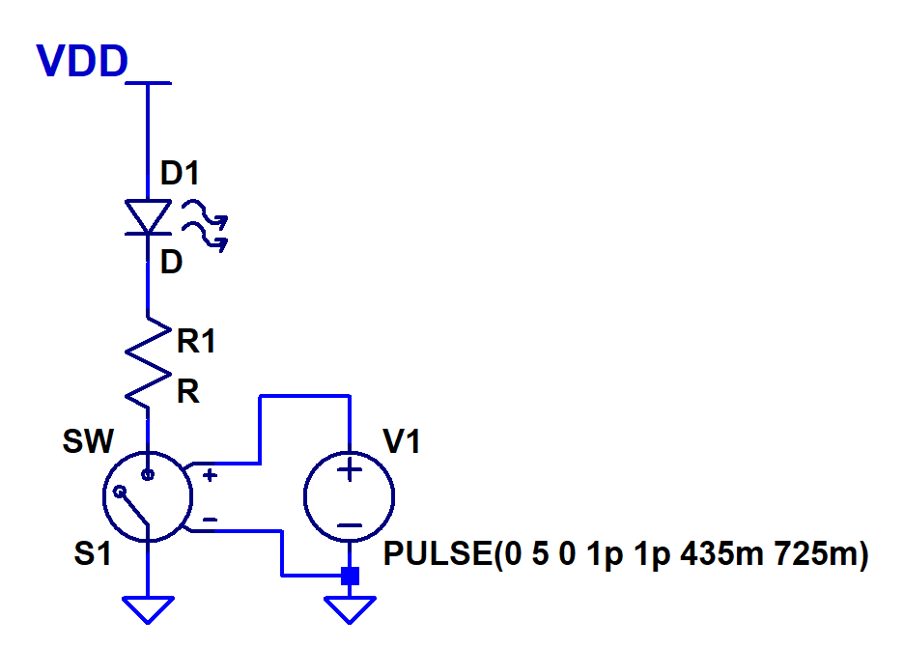

Button gets pressed, connects wire to ground. PB2 is connected to PC2 through the board, and the LED lights up for a time after the button is pressed.

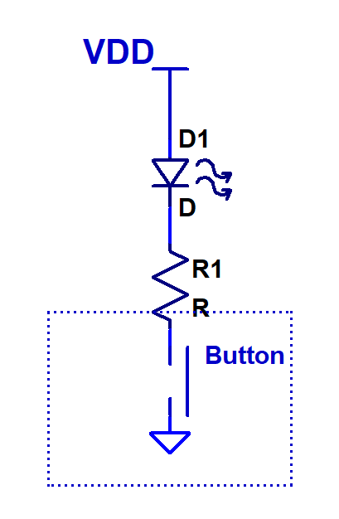

1. **SCREENSHOTS OF EACH TASK OUTPUT (ATMEL STUDIO OUTPUT)**

**PART 1A**

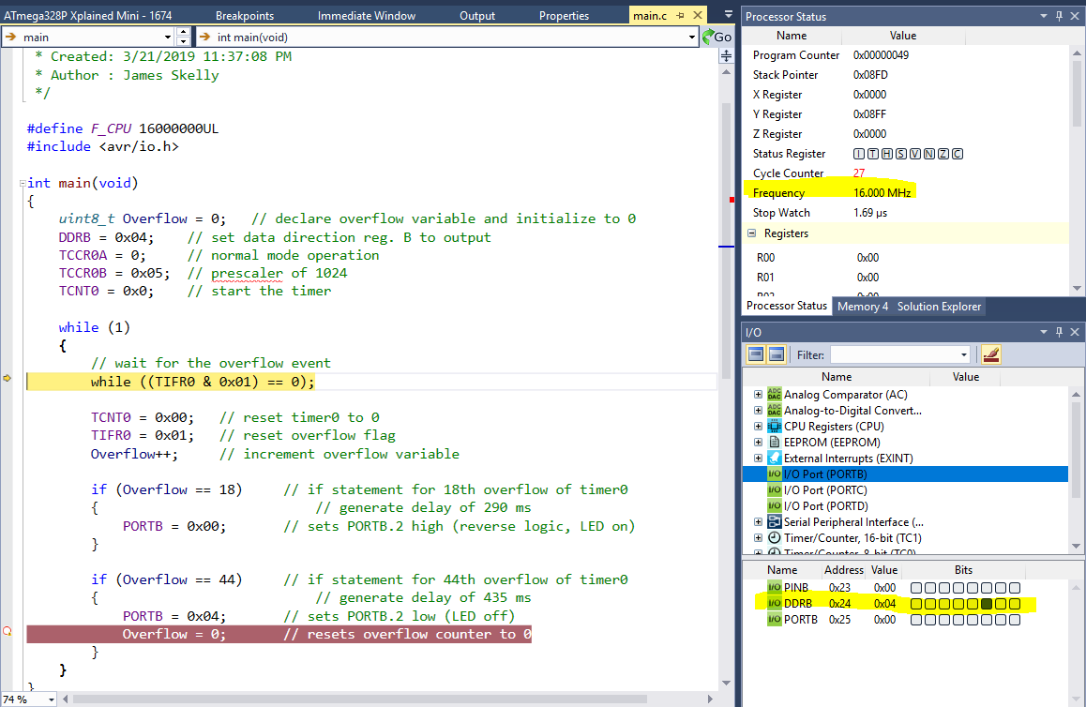

**PART 1B**

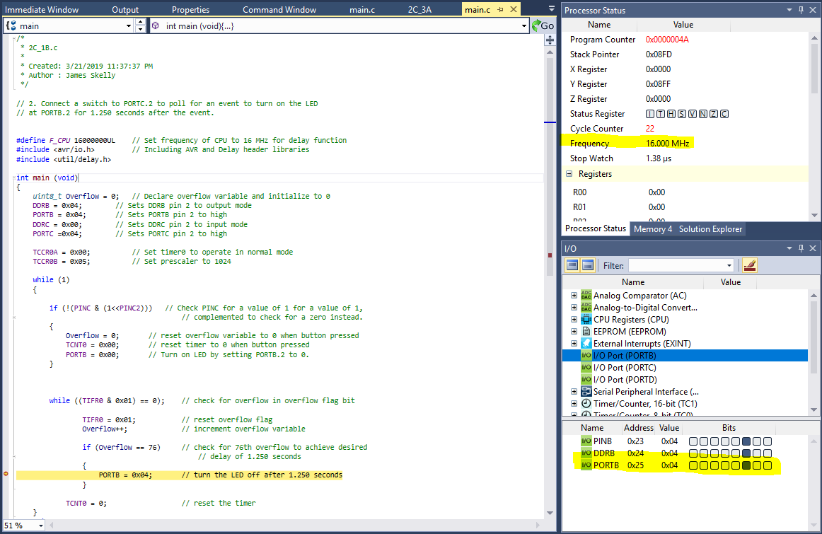

**PART 2A**

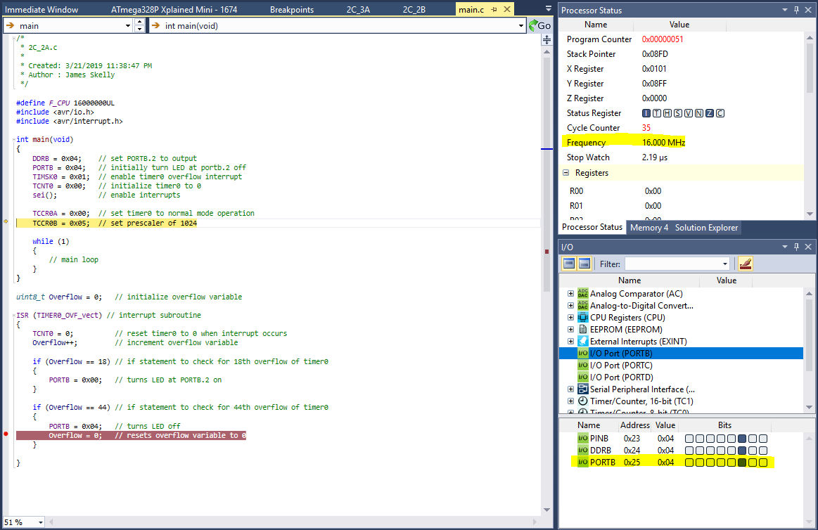

**PART 2B**

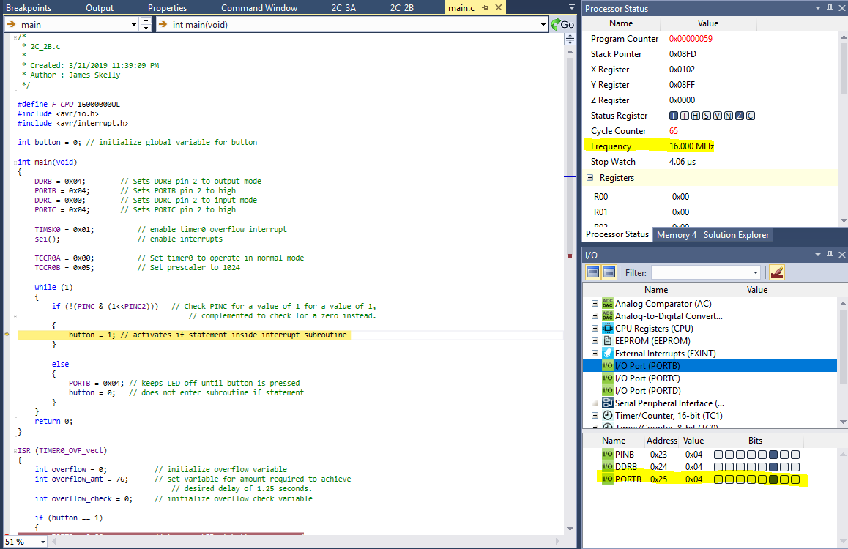

**PART 3A**

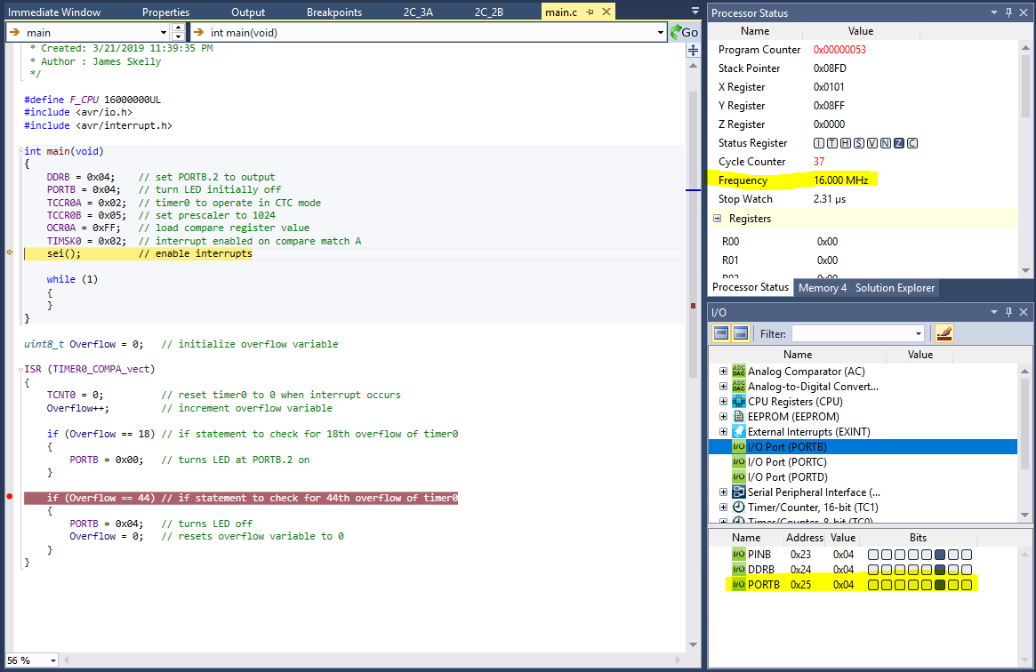

**PART 3B**

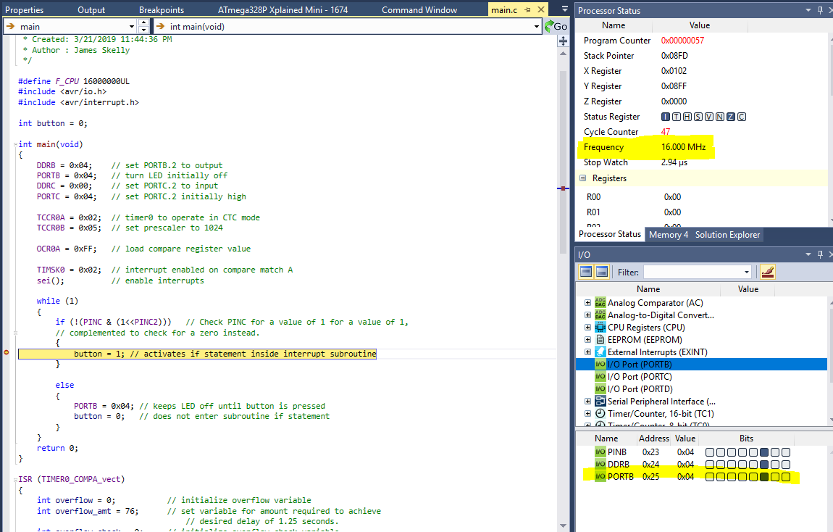

1. **SCREENSHOT OF EACH DEMO (BOARD SETUP)**

**Task 1A**

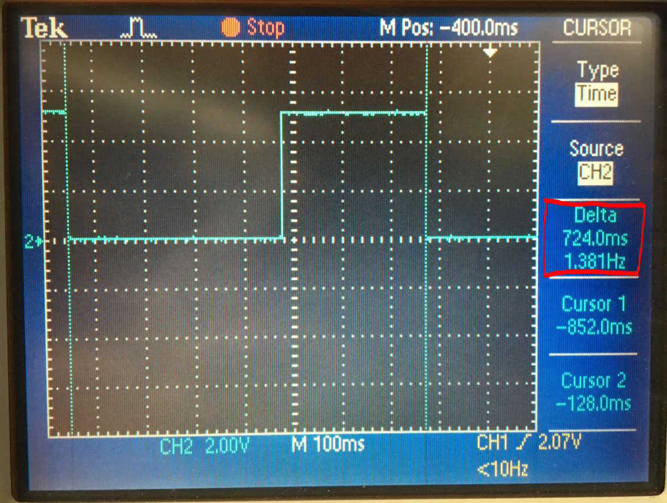

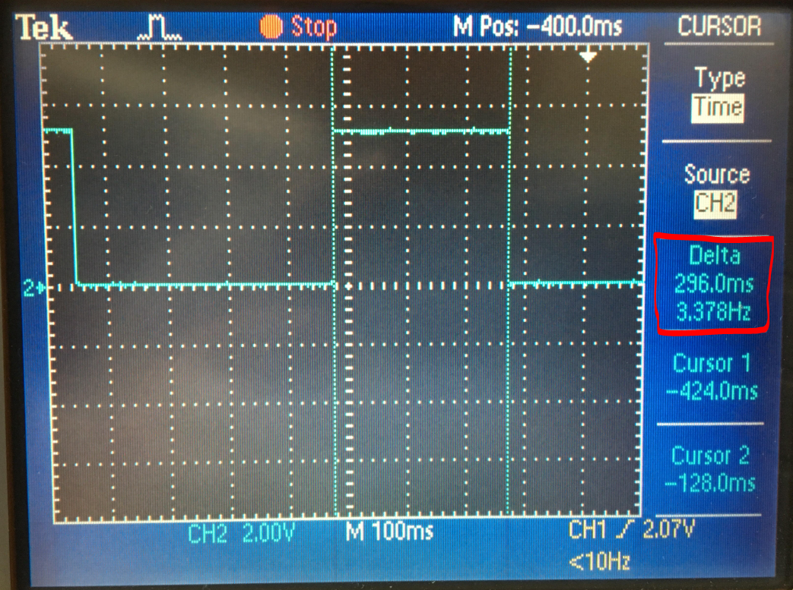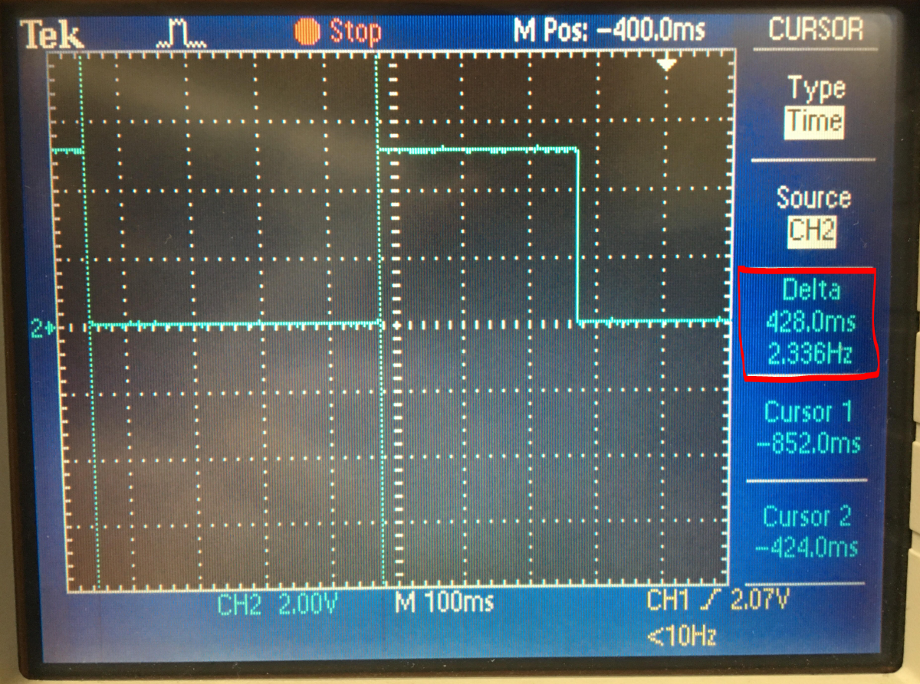

**Task 2A**

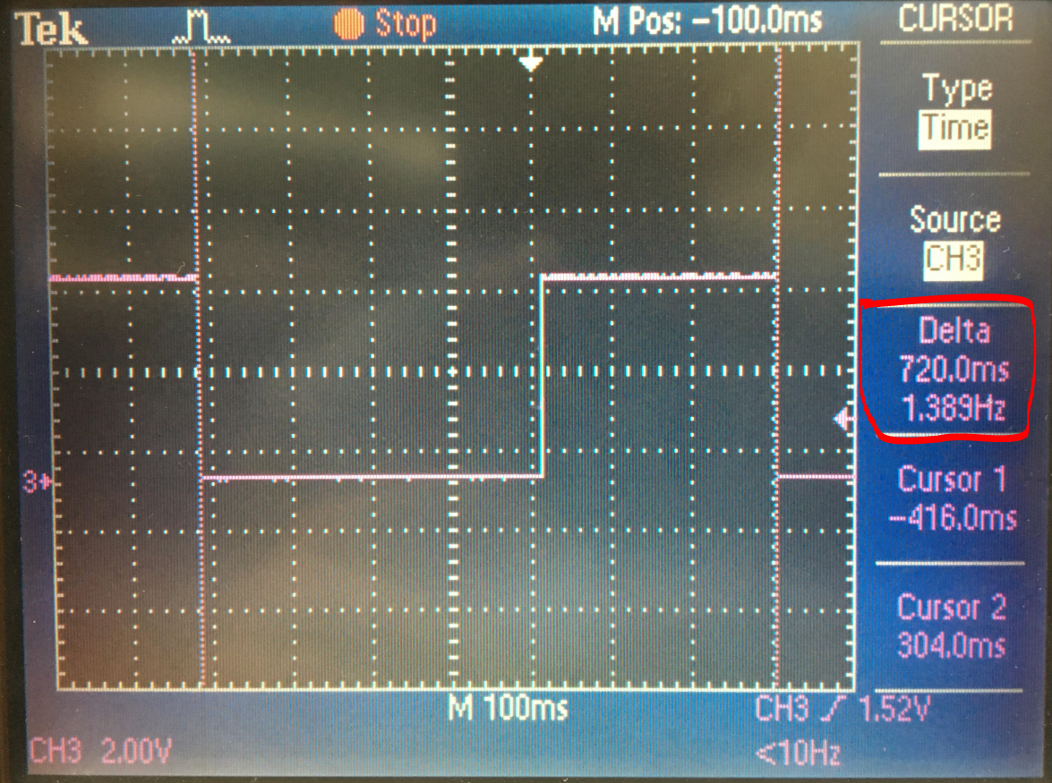

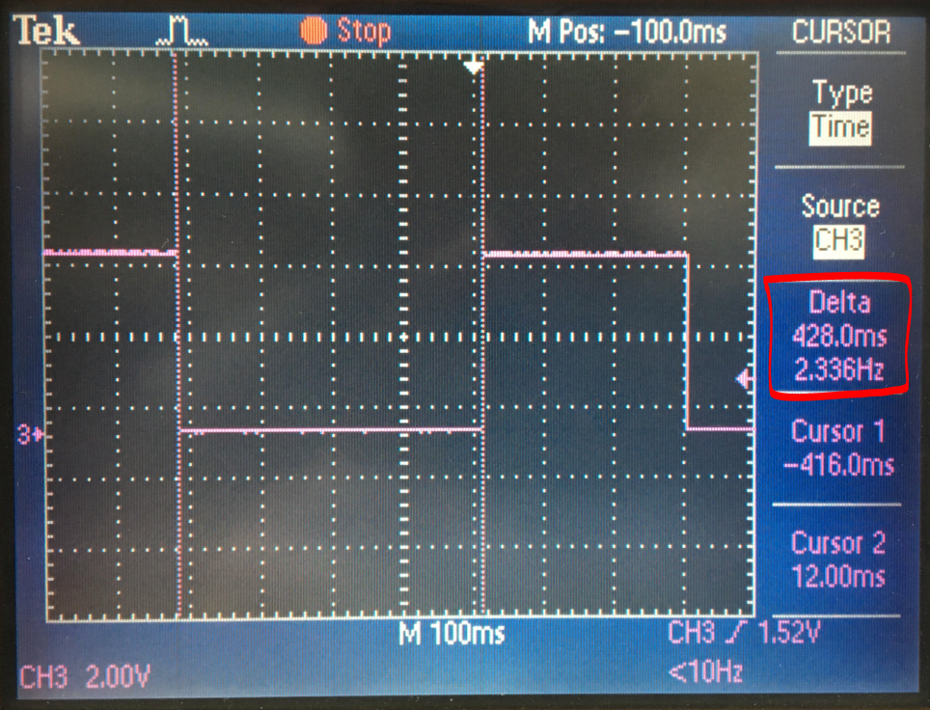

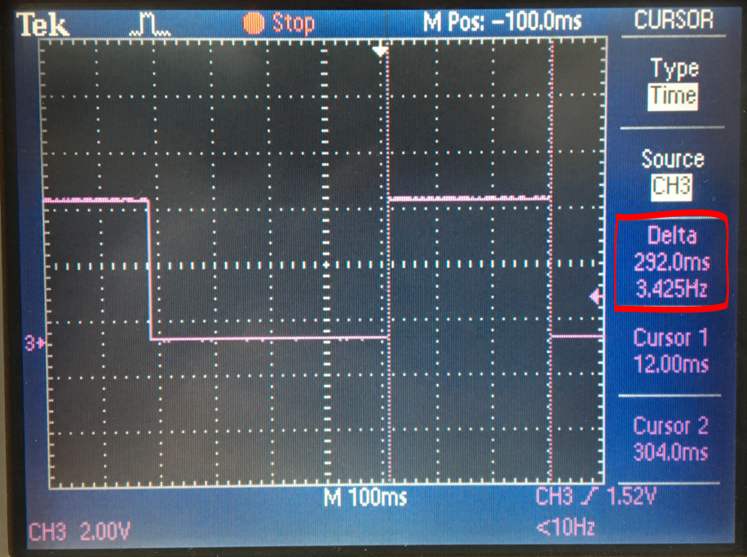

**Task 3A**

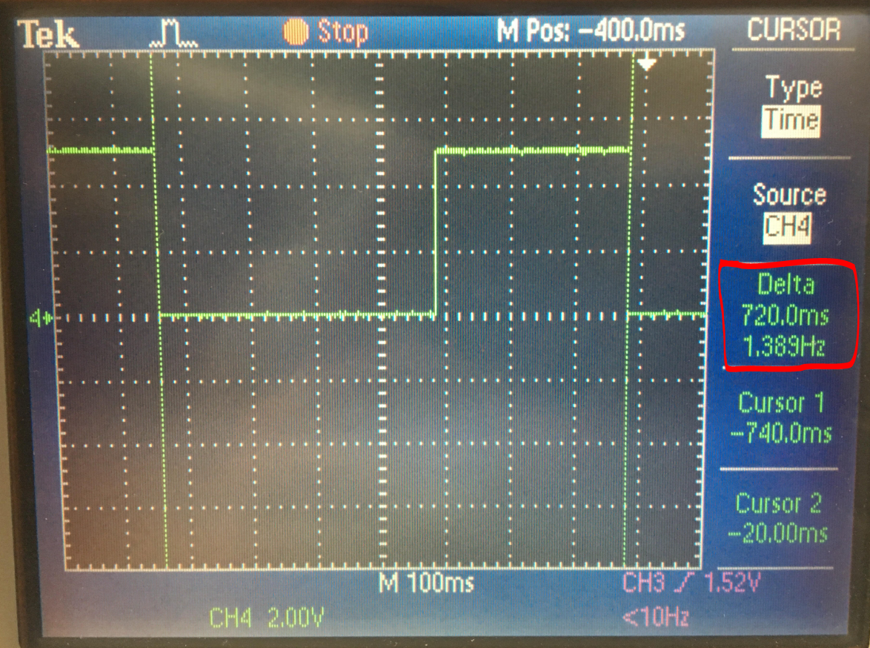

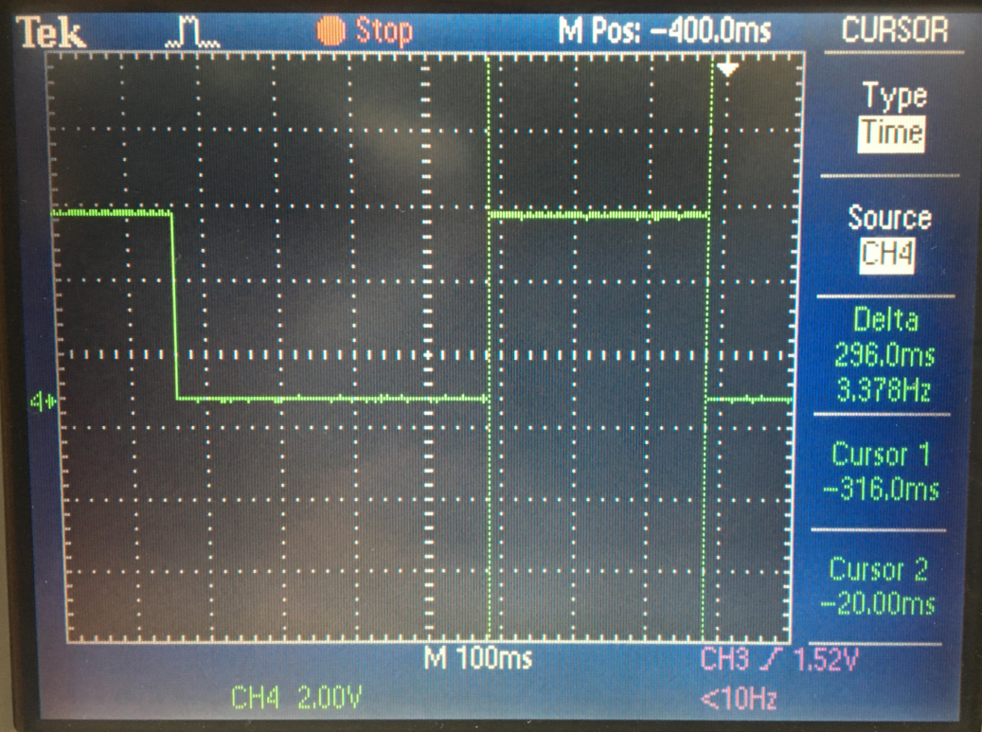

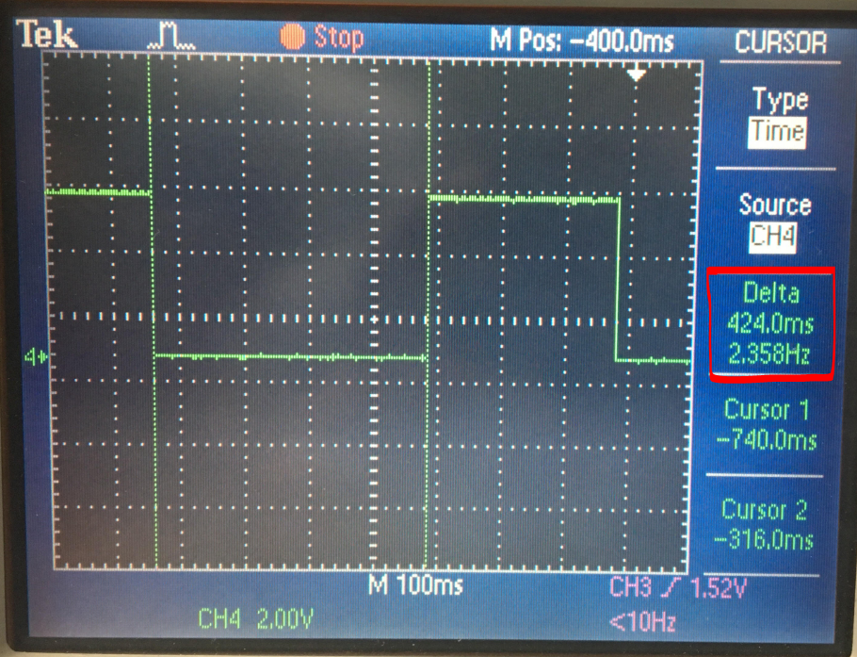

**Task 1B**

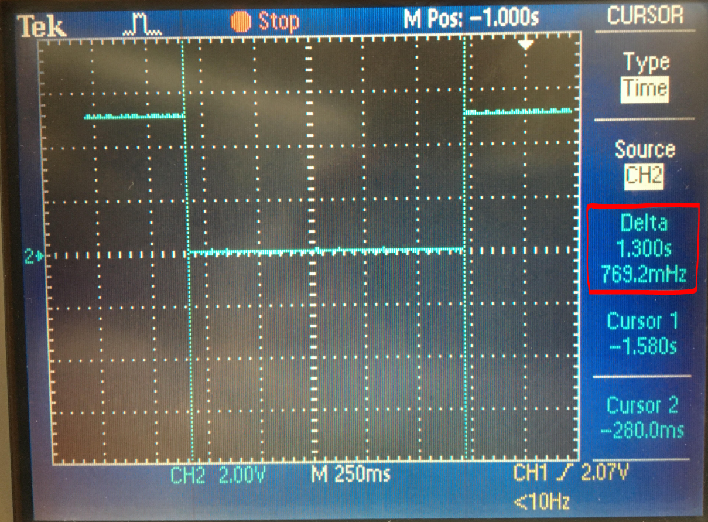

**Task 2B**

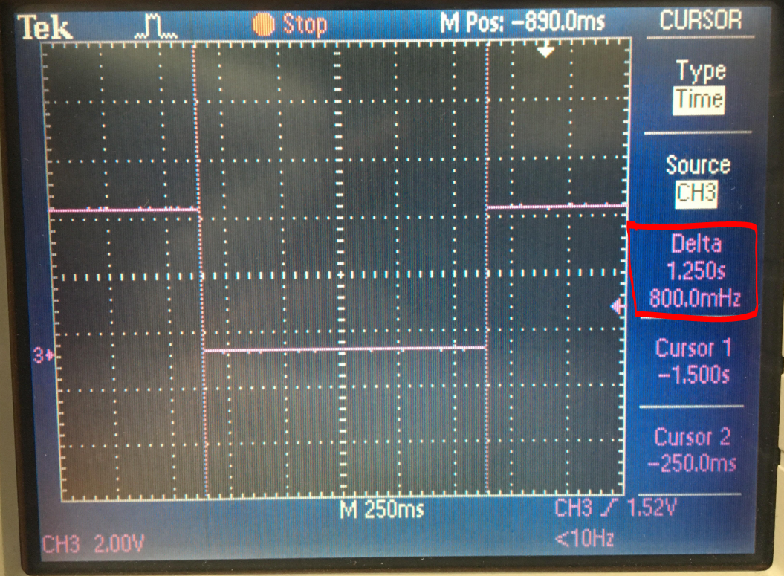

**Task 3B**

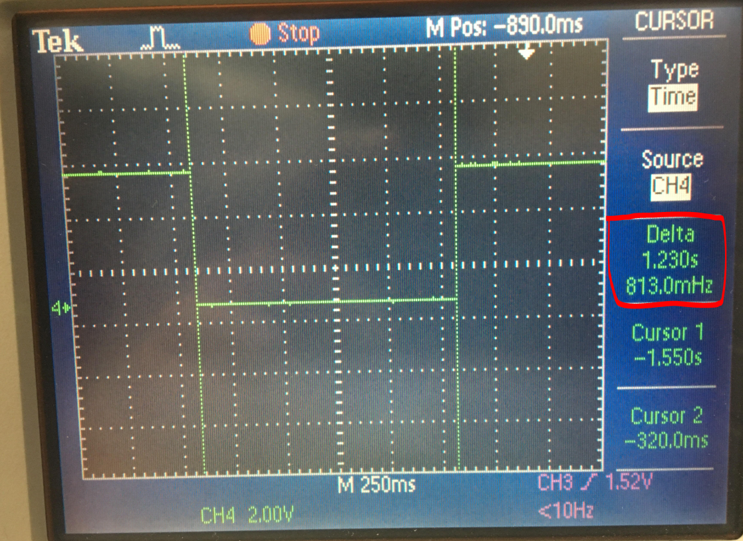

**The same board set up, shown below, was used for every part of the design assignment.**

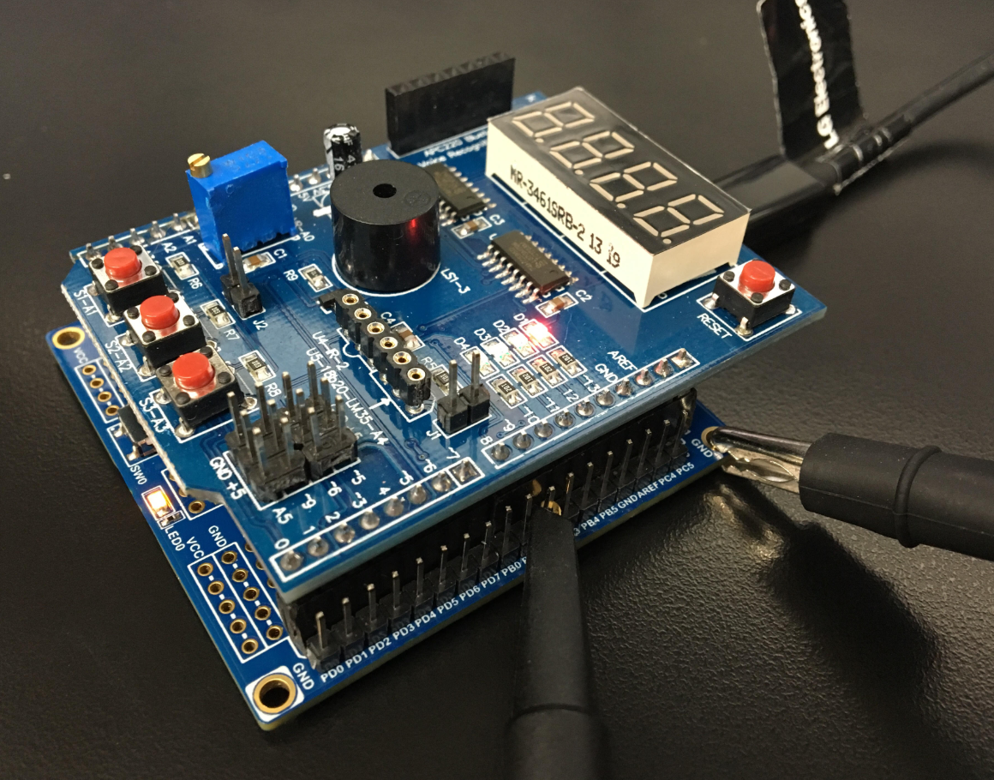

1. **VIDEO LINKS OF EACH DEMO**

**DA2C Part 1A**

[**https://www.youtube.com/watch?v=YTjuXlmjI6k**](https://www.youtube.com/watch?v=YTjuXlmjI6k)

**DA2C Part 1B**

[**https://www.youtube.com/watch?v=pFA_oJKaz0U**](https://www.youtube.com/watch?v=pFA_oJKaz0U)

**DA2C Part 2A**

[**https://www.youtube.com/watch?v=D1bpT4Hpnfg**](https://www.youtube.com/watch?v=D1bpT4Hpnfg)

**DA2C Part 2B**

[**https://www.youtube.com/watch?v=MDWpwpgFVWA**](https://www.youtube.com/watch?v=MDWpwpgFVWA)

**DA2C Part 3A**

[**https://www.youtube.com/watch?v=uaK8-E41RxU**](https://www.youtube.com/watch?v=uaK8-E41RxU)

**DA2C Part 3B**

[**https://www.youtube.com/watch?v=77TYOUd_ZcU**](https://www.youtube.com/watch?v=77TYOUd_ZcU)

1. **GITHUB LINK OF THIS DA**

<https://github.com/skellj1/submission_da>

**Student Academic Misconduct Policy**

<http://studentconduct.unlv.edu/misconduct/policy.html>

“This assignment submission is my own, original work”.

James W Skelly